# Reasons to Partition - Identifying the Incorrect Reason

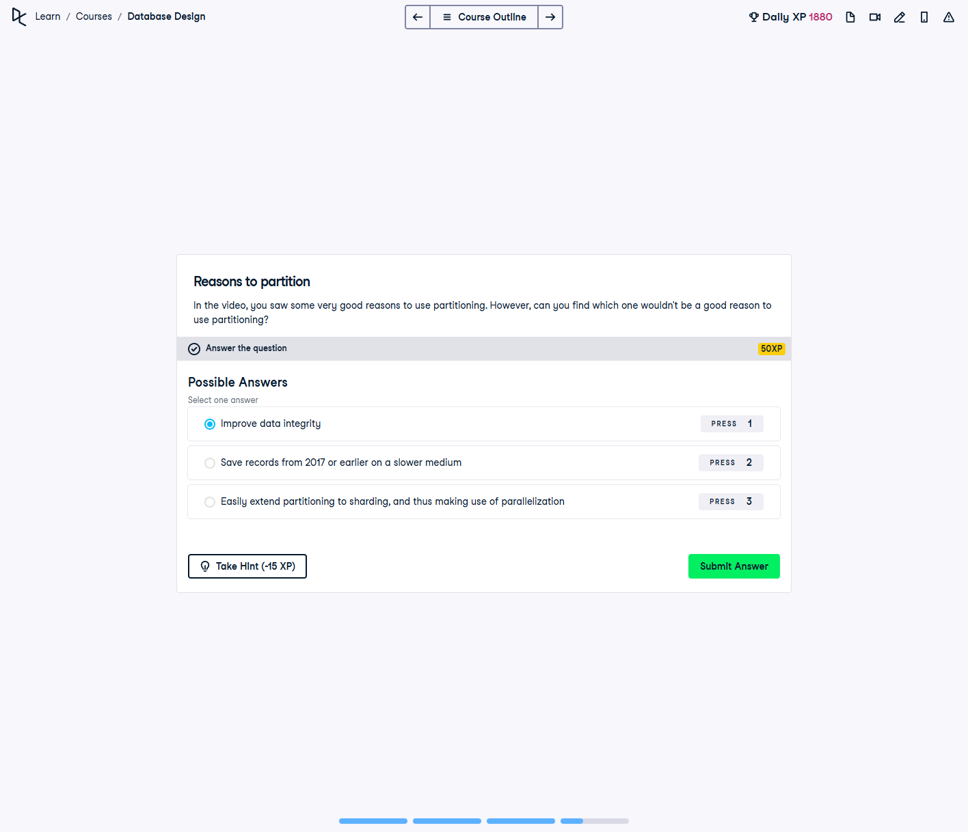

## Question:

In the video, you saw some very good reasons to use partitioning. However, can you find which one **wouldn't** be a good reason to use partitioning?

## Possible Answers:

1. Improve data integrity

2. Save records from 2017 or earlier on a slower medium

3. Easily extend partitioning to sharding, and thus making use of parallelization

## Correct Answer:

**Improve data integrity**

## Explanation of the Answer:

The correct answer is `Improve data integrity`. Partitioning is primarily used to enhance query performance, optimize storage, and facilitate data management. While it improves accessibility and scalability, it does not inherently enhance data integrity, which is maintained through constraints, validations, and indexing.